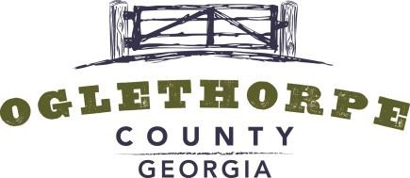

ZONING BOARD AGENDA

6 PM | MARCH 18, 2019

105 UNION POINT ROAD | LEXINGTON, GEORGIA
GENERAL
The members of the Zoning Board are residents of the community that have been appointed by the Board of
Commissioners to help review zoning applications and to make recommendations on zoning decisions. Any action taken by the Zoning Board is in the form of a recommendation to the Board of Commissioners. Zoning Board members are not compensated for their time and effort. The current Zoning Board members are: Jeff Sharp, Janet Hill, Morgan Robinson and Robert Drew.
AGENDA
6 PM. Call to Order
ITEM 1. Review of December Minutes.
ITEM 2. Election of Chair.
ITEM 3. Ms. Martha Jane Bowen has submitted a preliminary plat for her property on Bowen Farm Road known as Tax Parcel 071 002. The proposed subdivision will create four additional lots with frontage on Bowen Farm Road and Lanier Lane.
PROCEDURE
- Zoning Board Meetings are conducted as Open Meetings under the Official Code of Georgia §50-14.
- Meetings may be recorded.
- Staff will describe the applicant’s request.
- Zoning Board will recommend one of the following actions: Approval, Approval with Conditions, Table or Deny.
- Zoning Board will have 60 days or two regular meetings, whichever is greater, from the date the application is officially received to submit a recommendation to the Oglethorpe County Board of Commissioners.

