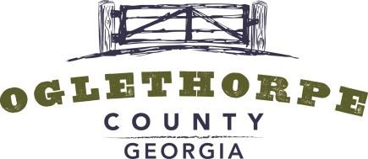

ZONING BOARD AGENDA

6 PM | May 20, 2019

105 UNION POINT ROAD | LEXINGTON, GEORGIA
GENERAL
The members of the Zoning Board are residents of the community that have been appointed by the Board of
Commissioners to help review zoning applications and to make recommendations on zoning decisions. Any action taken by the Zoning Board is in the form of a recommendation to the Board of Commissioners. Zoning Board members are not compensated for their time and effort. The current Zoning Board members are: Jeff Sharp, Janet Hill, Morgan Robinson and Robert Drew.
AGENDA
6 PM. Call to Order
ITEM 1. Review of April Minutes.
ITEM 2. Robert Jason Smith has requested a rezone of his property on Elberton Road, also known as Tax Parcel 162 039, from A2 (General Agriculture) to HI(me) (Heavy Industrial – Mineral Extraction) for a granite quarry operation.
ITEM 3. Catherine McDaniel has requested to rezone her property at 167 Smokey Ridge Road, also known as Tax Parcel 051 053, from AR (Rural Residential) to R1 (Single Family Residential) in order to create a lot for a residence.
PROCEDURE
- Zoning Board Meetings are conducted as Open Meetings under the Official Code of Georgia §50-14.
- Meetings may be recorded.
- Staff will describe the applicant’s request.
- Zoning Board will recommend one of the following actions: Approval, Approval with Conditions, Table or Deny.
- Zoning Board will have 60 days or two regular meetings, whichever is greater, from the date the application is officially received to submit a recommendation to the Oglethorpe County Board of Commissioners.

